E1

- As shown in the scatterplots below, first of all, the relationship is not linear. The Highway MPG drops as the horsepower increases, and the drop is especially sharp when horsepower is between 50 and 100. When horsepower exceed 100, the drop becomes less sharp. When horsepower is larger than 200, the relationship fluctuates, with 300 horsepower actually having higher Highway MPG than 200.
- Similarities: both LOESS line and B-spline captures the general pattern of the data, especially the negative relationship between horsepower and highway MPG when horsepower is between 50 and 100.
- Differences: the b-spline has a wider 95% CI compared with LOESS line when horsepower is high (higher than 200).
Also, when horsepower is between 50 and 200, the LOESS line fits more accurately, and reflects some fluctuations that are not shown by the b-spline. However, when the horsepower exceeds 200, the b-spline captures the pattern of the last 2 points, where higher horsepower is associated with higher Highway MPG.

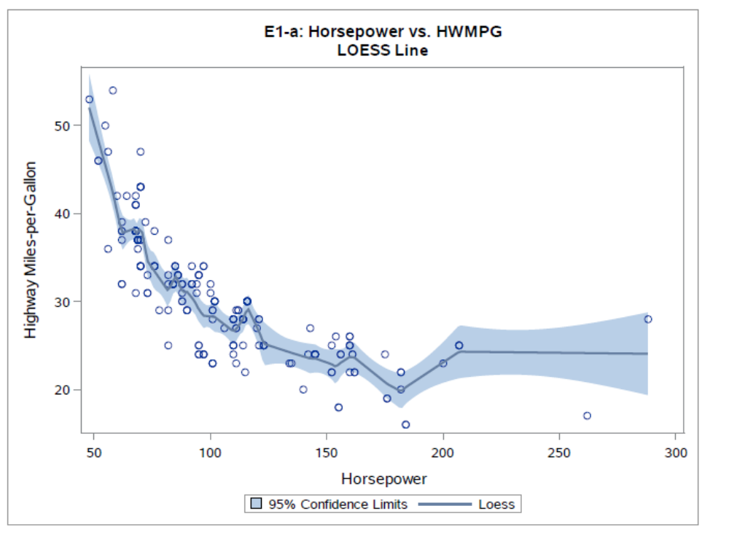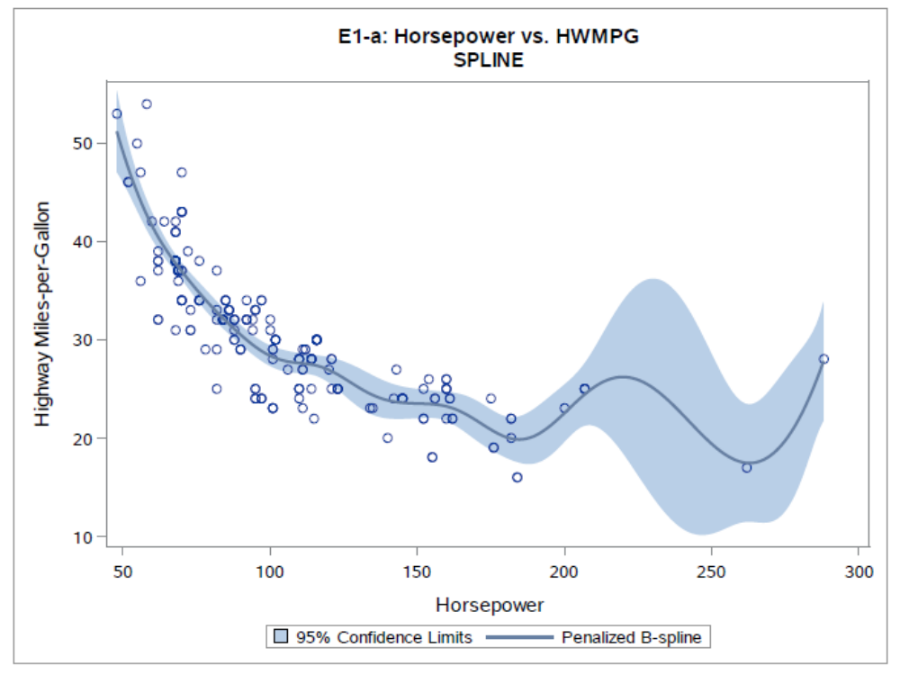

- t-test: As is shown below, the linear effect of horsepower is statistically significant (t-value=-25.82, p-value<.0001).
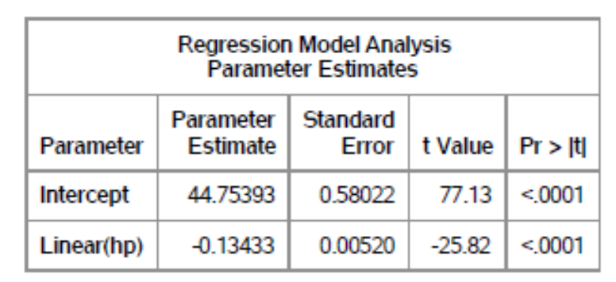
- Chi-square test: As is shown below, the nonparametric horsepower effect is statistically significant (chi-square value=270.3, p-value<.0001).
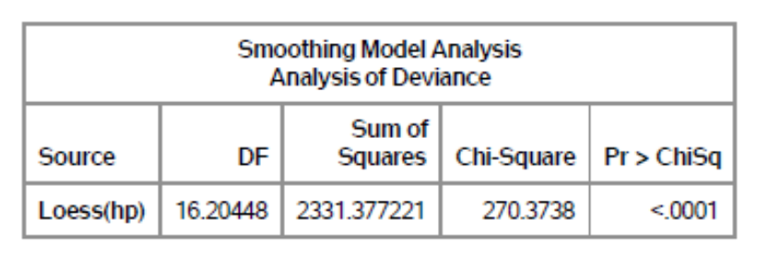

- As is shown below, the linear horsepower effect is still statistically significant (t-value=23.99, p-value<.0001).
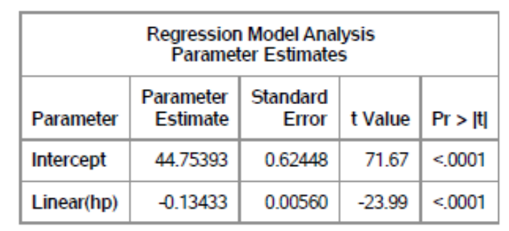
- As is shown below, the nonparametric horsepower effect is also statistically significant (chi-square value=194.49, p-value<.0001).
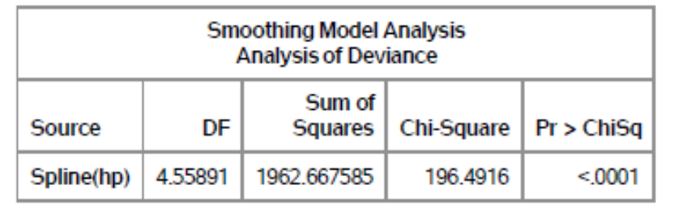

- As is shown below,
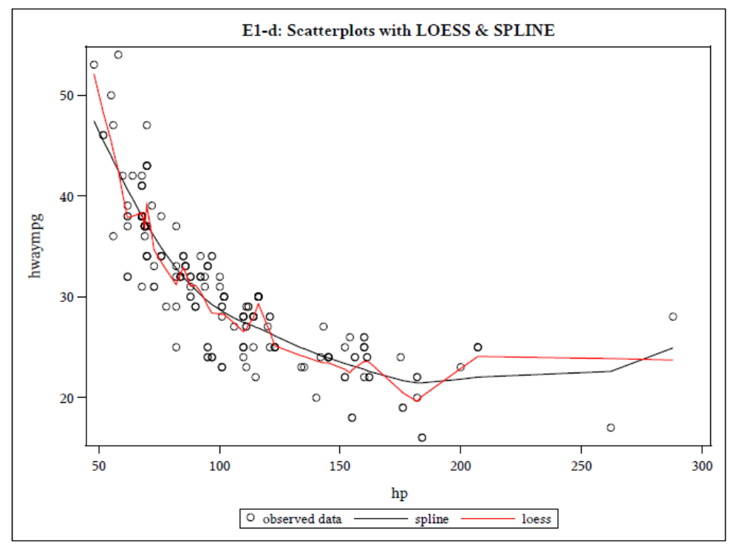

E2

- According to the table below, Type 1 has the lowest errors mean (3.63), while Type 4 has the highest (6.63). However, the 2 types have the same variance (5.41), which is also the largest among the 4 types.
- Type 2 and Type 3 have almost the same mean values (4.25 and 4.38), but the variances are very different, with Type 2 having much higher a variance (4.50) than Type 3 (1.70).
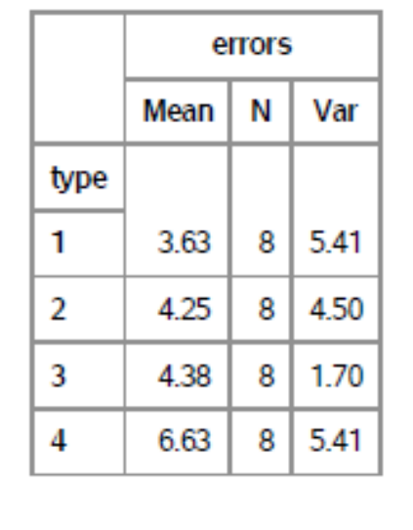

- As is shown below, altimeter type has a statistically significant effect on reading errors (F-value=9.36, p-value=.0004).
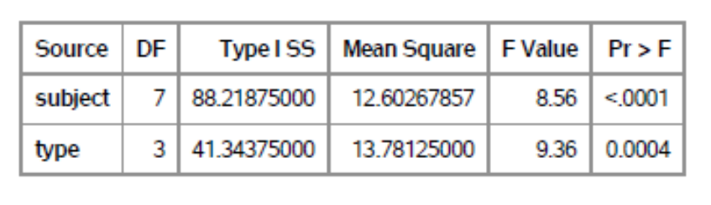
As is shown below, Type 4 is significantly different from all the other 3 types, but Type 1, 2, and 3 are not significantly difference from each other.
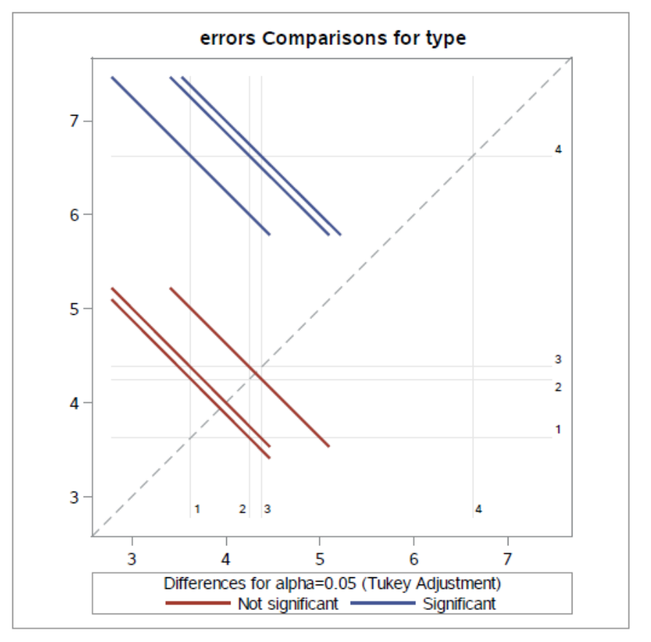

- The tables below show that
- In terms of reading error numbers, Type 1 and Type 4 have statistically significant mean difference (F-value=14.82, p-value=.006).
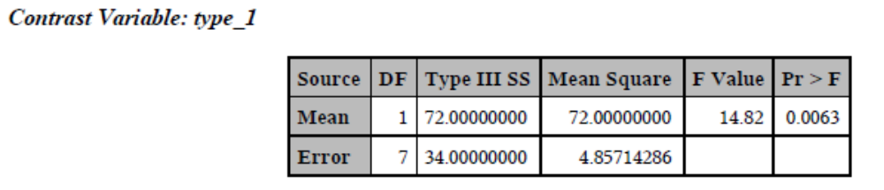
- In terms of reading error numbers, Type 2 and Type 4 have statistically significant mean difference (F-value=7.92, p-value=.026).
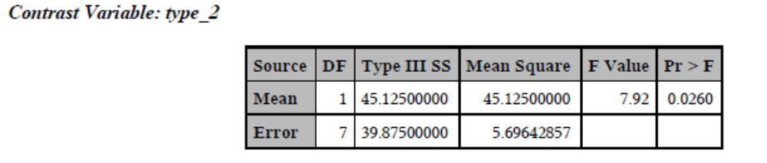
- In terms of reading error numbers, Type 2 and Type 4 have statistically significant mean difference (F-value=13.19, p-value=0.0084).
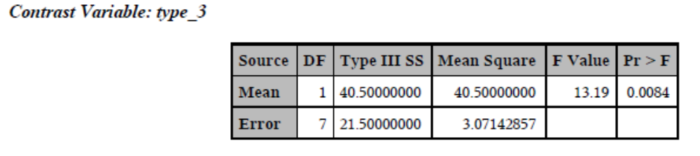
This is consistent with what we got from the Tukey’s pairwise comparison from E2-b.

